**Firecrest Mountain Biking – Team Kit Order Form 2018**

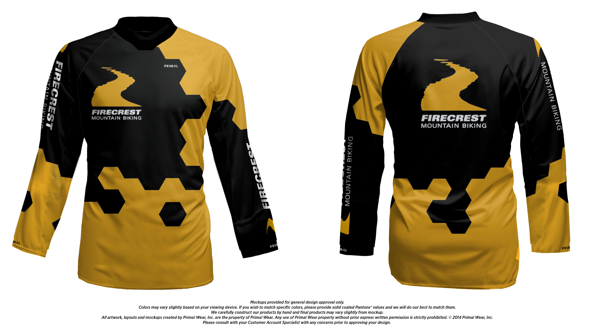

I am taking orders for the 2018 Firecrest Mountain Biking Jersey. The jersey will be produced by Primal Clothing as a custom downhill jersey design for Firecrest MTB.

We have chosen their Custom DH Jersey for the material, cut and fit as it designed for pads and body armor. As a result the tops come up quite large and most people that have tried them on are going for a size smaller than they would usually wear (e.g. Medium = Small). Please bear this in mind when sizing your order as we won’t be able to offer an exchange or refund on these custom orders.

**Please Note: This the second order for the Team Kit and we need a minimum of 10 garments to place the order. As soon as we have an order for 10 garments I will place the order with Primal and I will e-mail you with the expected delivery date.**

**Your Order Details:**

|  |  |  |  |
| --- | --- | --- | --- |
| First Name |  | Surname |  |
| Contact Tel No |  | |  |
| Contact E-mail |  | |

|  |  |  |
| --- | --- | --- |
| Size | Quantity | Total (x£45) |
| XS |  |  |
| S |  |  |
| M |  |  |
| L |  |  |
| XL |  |  |
| Total |  |  |

**Please complete and send the Booking Form to** [**ian@firecrestmtb.com**](mailto:ian@firecrestmtb.com) **and transfer the amount due to the following Lloyds Bank Account to pay for your order:**

**Firecrest MTB - Bank Account details: Sort Code: 30-97-77 Account No. 20531668**

**Please use your Booking Reference ‘Jersey/Surname’ so that we can attribute this transfer/s directly to you.**